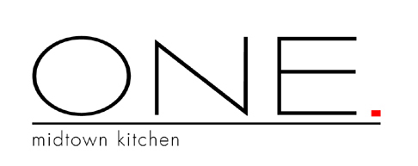

Special Large Party Menu
$50 per person, plus tax plus gratuity

Small Plates
Goat Cheese
Calamari
Lamb Ribs
Chicken Saytays
Wood Oven Pizza

Salad
Spiced walnuts, blue cheese,
grilled pear vinaigrette.

Entrée
(choice of)

Steak Frites
Chargrilled hanger steak, parmesan-herb fries
red wine shallot sauce.

Chicken
Hickory grilled, pappardelle asparagus
black truffle butter.

Salmon
Pancetta, apple & leek turnover,
fried apple rings.

Dessert
(Choice of)

Chocolate Kit-Kat
Buttermilk Panna Cotta

Chef-Tom Harvey

