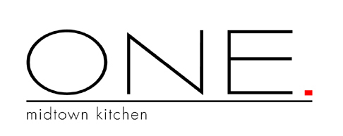
11

Special Large Party Menu
$60.00 per person, plus tax, plus gratuity

Small Plates
Calamari
Lamb Ribs
Wood Oven Pizza
Chicken Satays
Goat Cheese

ONE Soup
Celery Root, olive Oil, potato,
yukon chip.

Salad
Spiced walnuts, blue cheese,
grilled pear vinaigrette.
.

Entrée
Choice of

Steak Frites
Chargrilled hanger steak, parmesan-herb fries,
red wine shallot sauce.

Chicken
Hickory grilled, pappardelle asparagus
black truffle butter.

Salmon
Pancetta, apple & leek turnover,
fried apple rings.

Tuna
Fresh Georgia lady peas,
Worcestershire glaze

Dessert
Choice of
Chocolate Kit-Kat
Buttermilk Panna Cotta
Chocolate Truffle Cake

Chef-Tom Harvey

